**SQL: MINI PROJECT**

**Aim:**

To Design a mini project using python as frontend and MySQL as database.

**Home Page**

**Code:**

import sqlite3

from tkinter import *

from tkinter import messagebox

# Connect to SQLite database

mydb = sqlite3.connect("college.db")

mycursor = mydb.cursor()

# Function to create tables for course registration

def create_tables():

mycursor.execute('''CREATE TABLE IF NOT EXISTS courses (

id INTEGER PRIMARY KEY,

name TEXT,

code TEXT,

instructor TEXT,

semester TEXT,

credit_hours INTEGER)''')

mydb.commit() # Commit the changes after table creation

# Call create_tables() function to ensure that the table exists

create_tables()

# Function to register a course

def register_course():

name = name_entry.get()

code = code_entry.get()

instructor = instructor_entry.get()

semester = semester_entry.get()

credit_hours = int(credit_hours_entry.get())

sql = "INSERT INTO courses (name, code, instructor, semester, credit_hours) VALUES (?, ?, ?, ?, ?)"

val = (name, code, instructor, semester, credit_hours)

mycursor.execute(sql, val)

mydb.commit()

messagebox.showinfo("Success", "Course registered successfully!") # Show a message box

# Function to display course details

def display_course_details():

mycursor.execute("SELECT * FROM courses")

course_details = mycursor.fetchall()

# Create a new window to display course details

display_window = Tk()

display_window.title("Course Details")

for i, course in enumerate(course_details):

course_label = Label(display_window, text=f"Course {i + 1}:")

course_label.pack()

course_info = f"Name: {course[1]}, Code: {course[2]}, Instructor: {course[3]}, Semester: {course[4]}, Credit Hours: {course[5]}"

course_info_label = Label(display_window, text=course_info)

course_info_label.pack()

# GUI

root = Tk()

root.title("Course Registration System")

# Course Registration Interface

name_label = Label(root, text="Course Name:")

name_label.grid(row=0, column=0)

name_entry = Entry(root)

name_entry.grid(row=0, column=1)

code_label = Label(root, text="Course Code:")

code_label.grid(row=1, column=0)

code_entry = Entry(root)

code_entry.grid(row=1, column=1)

instructor_label = Label(root, text="Instructor:")

instructor_label.grid(row=2, column=0)

instructor_entry = Entry(root)

instructor_entry.grid(row=2, column=1)

semester_label = Label(root, text="Semester:")

semester_label.grid(row=3, column=0)

semester_entry = Entry(root)

semester_entry.grid(row=3, column=1)

credit_hours_label = Label(root, text="Credit Hours:")

credit_hours_label.grid(row=4, column=0)

credit_hours_entry = Entry(root)

credit_hours_entry.grid(row=4, column=1)

# Register button

register_btn = Button(root, text="Register Course", command=register_course)

register_btn.grid(row=5, columnspan=2)

# Display button

display_btn = Button(root, text="Display Course Details", command=display_course_details)

display_btn.grid(row=6, columnspan=2)

root.mainloop()

**COURSE REGISTER:**

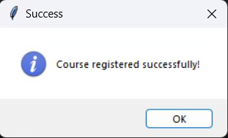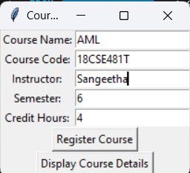

**DATABASE:**

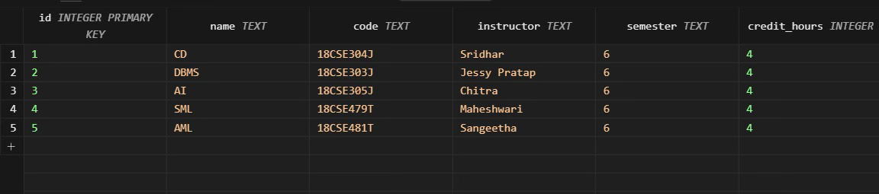

**DISPLAY:**

